Introduction
This report provides an overview of my internship experience at a transformer manufacturing company. It highlights the key processes involved in the production of electrical transformers, including core cutting, coil winding, core-coil assembly, oil filling, and final testing. The internship offered valuable practical exposure to industrial machinery, safety protocols, and quality control methods used in modern transformer manufacturing.

Core Cutting Machine – Overview

A Core Cutting Machine is a precision machine used to cut CRGO (Cold Rolled Grain Oriented) steel sheets into specific shapes and sizes to form the core laminations of transformers. These cores are critical for the transformer's magnetic circuit and efficient energy transfer.

⚙ Types of Core Cutting Machines
Step Lap Core Cutting Machine
Produces step-lap joints for improved flux distribution and lower core loss.
Rectangular Core Cutting Machine
Cuts straight limbs for rectangular core designs.
Toroidal Core Cutting Machine
Specially for toroidal transformers.
V Notch & Hole Punching Core Cutting Machine
Performs cutting along with hole punching for bolt and assembly fitment.

🔧 Working Principle
The machine uses servo-controlled blades or rotary shears to cut CRGO sheets. Based on pre-set dimensions, the CNC system controls the cutting operation with high precision.

Key Processes:
Feeding – CRGO coil is unwound and fed into the machine.
Measuring & Marking – Dimensions are calculated via sensors or programmed logic.
Cutting – Hydraulic or servo blades make angular or straight cuts.
Notching – Holes or V-notches are punched where needed.
Stacking – Finished laminations are stacked or discharged automatically.

🧩 Main Components
Component Function
Uncoiler Holds and unwinds CRGO coil
Straightener Flattens the steel before cutting
Servo Feeder Feeds material precisely to cutting area
Cutting Blade/Tool Cuts material based on CNC input
Punching Unit Punches holes or notches for assembly
CNC Controller Controls the machine operation digitally
Stacker or Conveyor Collects finished laminations after cutting

📐 Types of Cuts Made
45° or 135° Bevel Cuts
90° Straight Cuts
Step-lap Cuts
Mitred Corners
V-Notch and Bolt Holes

✅ Advantages
High precision and repeatability
Reduces material wastage
Increases efficiency and speed
Improves transformer performance via accurate core design
Reduces no-load losses in transformer core

🛠 Applications
Power Transformers
Distribution Transformers
Instrument Transformers
Toroidal and Rectangular Core Transformers

Slitting Machine – Overview

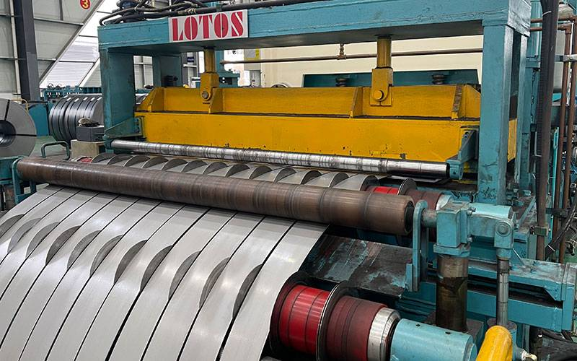
A Slitting Machine is used to cut wide coils of CRGO (Cold Rolled Grain Oriented) steel into narrower strips. These strips are then used in transformer core cutting and assembly. It is one of the first steps in core fabrication and ensures the required width and edge quality for further processing.

⚙ Purpose in Transformer Manufacturing
Prepare CRGO steel sheets in specific widths for use in core cutting machines.
Maintain accuracy in strip width, reduce burrs, and ensure clean edges.

🔧 Working Principle of a Slitting Machine
The slitting machine works by feeding a wide steel coil through a series of rotary slitting knives mounted on arbors. These knives rotate and shear the coil into narrower strips of desired widths.

🔄 Step-by-Step Working Process
Uncoiling
The large CRGO coil is placed on the uncoiler stand.

The coil is unwound in a controlled manner.
Straightening (Optional)
Some machines have a straightener to flatten the coil before slitting.
Slitting
The sheet passes through rotary knives (upper and lower circular blades).
The blades slit the coil into multiple narrow strips.
The distance between knives is adjusted based on required strip widths.
Tensioning/Looping
A tension device or loop pit maintains consistent strip tension.
Recoiling
The slit strips are rewound into individual coils on the recoiler shaft.
Discharge

The finished coils are removed for use in core cutting.

🧩 Main Components of a Slitting Machine
Component Function
Uncoiler Holds and unwinds the master coil
Feeder Unit Controls speed and feeds coil into slitting knives
Slitting Head Contains rotary knives to slit the coil
Separator Discs Maintain alignment and prevent strip overlap
Tension Unit Maintains consistent strip tension
Recoiler Rewinds the slit strips into coils
Strip Guides Aligns and guides strips during slitting
Control Panel (PLC/CNC) Automates and manages the entire slitting process

📐 Output Example
If the input coil is:
Width = 1000 mm
You want strips of 100 mm width
Then, the slitting machine will produce 10 strips of 100 mm width from the same coil.

✅ Advantages of Slitting Machine
High cutting speed and precision
Minimal edge burrs
Consistent strip quality
Efficient material utilization
Automation reduces labor and increases safety

🛠 Applications
CRGO Slitting for Transformer Core
Electrical Steel Preparation
Coil Processing in Steel Industry
Cable and Wire Industry

Core Stacking Table – Overview
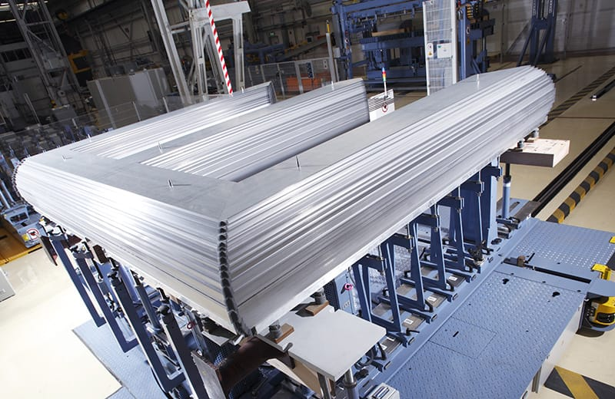

A Core Stacking Table is a specialized mechanical workstation used to assemble and align the laminated core sheets (cut from CRGO steel) into a complete transformer core. It ensures correct orientation, alignment, and stability of the core limbs and yokes during the stacking process.

This is a critical step in transformer core manufacturing that affects magnetic performance, loss levels, and noise.

⚙ Purpose in Transformer Manufacturing
Helps in assembling the core limbs and yokes accurately.
Ensures tight stacking of CRGO laminations.
Allows easy insertion of HV and LV coils during core assembly.
Reduces core loss, leakage flux, and improves overall transformer efficiency.

🔧 Working Principle of a Core Stacking Table
The table is designed to support the vertical or horizontal stacking of CRGO laminations. Using hydraulic or mechanical lifting mechanisms, the table lowers or raises parts of the core to allow easy insertion of coils or limb assembly. After stacking, the core is clamped and compacted to minimize air gaps.

🔄 Step-by-Step Working Process
Lamination Preparation
Laminations cut using the core cutting machine are arranged as per core design (E-I or step-lap).
Base Placement
Yoke (horizontal laminations) is placed first on the table.
Vertical Limb Stacking
Laminations are stacked vertically between guiding fixtures.
Multiple sheets are stacked in a staggered or step-lap manner to reduce magnetic loss.
Hydraulic Lift (Optional)
Some tables lower the center portion to insert transformer coils.
Once coils are in place, limbs are passed through the coil windows.
Upper Yoke Placement
Once the limbs are complete, the upper yoke is stacked on top.
Clamping and Final Adjustment
The complete core is clamped and tightened to compress laminations.
Measurements and squareness are checked for accuracy.
Lifting / Tilting

The assembled core may be lifted or tilted (using hydraulics or crane) for further assembly or transport.

🧩 Main Components of Core Stacking Table
Component Description
Table Frame Rigid steel platform to support laminations
Guide Rails/Fixers Ensures proper alignment of laminations
Hydraulic Lift Mechanism Moves sections of the table up/down to allow coil insertion
Tilting System Allows tilting the core into vertical position for easier handling
Clamping Mechanism Compresses laminations to minimize air gaps
Control Panel Manual or motorized control of lifting, tilting, and clamping

🧪 Types of Cores Assembled
Three-Limb Core
Five-Limb Core
Rectangular or Cruciform Core
Step-Lap Core Assembly

✅ Advantages
Accurate lamination alignment reduces core loss
Easy and safe handling of heavy laminations
Allows coil insertion during stacking
Reduces manual labor and improves precision
Minimizes deformation and gap issues in core

🛠 Applications
Power Transformer Core Assembly
Distribution Transformer Core Stacking
Dry-type Transformer Assembly
Reactor Core Assembly

___________________________________________________________________

Coil Winding Machine – Complete Overview

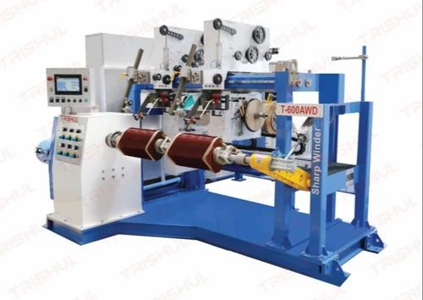

🔹 What is a Coil Winding Machine?
A Coil Winding Machine is an industrial machine used to wind wire (usually copper or aluminum) into coils of specific shapes and sizes. These coils are essential for electromagnetic devices like transformers, motors, inductors, and generators.

In a transformer, these coils form the primary and secondary windings, which are responsible for transferring energy through electromagnetic induction.

🧭 Working Principle
The basic operation involves:
Holding the coil form (bobbin or core) in place on a rotating spindle.
Feeding the wire through a tension control and guiding system.
Rotating the spindle while guiding the wire in a controlled manner to create precise layers.
The machine can be manual, semi-automatic, or fully automatic (CNC controlled).
For transformers, insulation and layering are critical to ensure electrical strength and thermal performance.

🛠 Main Components and Functions
Component Function
Spindle/Mandrel Rotates the coil form (core or bobbin) during winding.
Wire Tensioner Controls the tension of wire to prevent breaks or slack.
Wire Guide Accurately guides the wire for uniform winding.
Traverse Mechanism Moves back and forth to layer wire across the bobbin evenly.
Counter/Encoder Tracks the number of turns made during winding.
Drive Motor Powers the rotation of the spindle.
Control Panel/CNC Unit Controls speed, tension, pitch, layering, and stop-start functions.
Safety Shields Ensures operator safety during operation.

🔄 Types of Coil Winding Machines
Type Description
Manual Winding Machine Operated by hand; used in small workshops or for repairs.
Semi-Automatic Machine Operator sets parameters; machine does the winding.
Fully Automatic (CNC) Pre-programmed and automated; ideal for precision and high-volume production.
Horizontal Winding Machine Used for large power transformer LV/HV coils (especially disk or helical coils).
Vertical Winding Machine Suitable for cylindrical or circular core coils in large transformers.

⚙ Technical Parameters (Example for CNC Winder)
Parameter Typical Range
Conductor type Copper/Aluminum (Round/Rectangular)
Wire diameter range 0.2 mm – 5 mm
Winding speed Up to 1200 RPM
Coil length Up to 3000 mm
Max. coil weight 1000 kg or more (depending on the machine)
Programmable features Number of turns, pitch, layer insulation

📌 Applications in Transformer Manufacturing
Primary and Secondary Winding Coils
HV & LV Coil Winding (Helical, Disc, Layer types)
Toroidal Core Winding
Distribution and Power Transformer Coils

✅ Advantages
High precision and uniform winding
Reduced material waste
High-speed production
Consistent quality
Programmable for complex coil shapes

❌ Challenges / Maintenance Needs
Wire breakage due to improper tensioning
Overheating of motor if overloaded
Precise alignment required to avoid cross-layering
Regular lubrication and calibration needed
Dust buildup in CNC panel must be cleaned

____________________________________________________________________

Core Coil Assembly Station – Detailed Working and Overview


🔹 What is a Core Coil Assembly Station?
The Core Coil Assembly Station is the area where the active parts of the transformer — the core and the wound coils — are assembled into a complete magnetic and electrical structure. This step is vital to the overall functioning of the transformer, as it determines the alignment, structural integrity, and dielectric clearances of internal components.

🧭 Purpose and Function
To assemble transformer cores with HV (High Voltage) and LV (Low Voltage) windings.
To ensure accurate positioning of coils around the core limbs or legs.
To maintain electrical clearances, mechanical strength, and dimensional accuracy.
To support final clamping, insulation fitting, and core stacking for magnetic circuit completion.

🛠 Main Equipment and Tools in Core Coil Assembly Station
Tool/Equipment Purpose
Core stacking table/platform For positioning and stacking core laminations or core legs
Hydraulic/Manual lifting tools To lift and position the heavy coils onto the core
Assembly fixtures and jigs Ensure coils align properly on the core limbs
Clamping tools/frames Used to apply uniform pressure and secure the assembled structure
Measuring tools (vernier, micrometers, gap gauge) To verify insulation gaps and positioning accuracy
Insulation materials For placing pressboard barriers, spacers, and end insulation

⚙ Working Steps of Core Coil Assembly Process
🔧 Step-by-Step Process:
Preparation of Core
The core limbs (assembled from laminated sheets) are stacked on the core stacking table.
Yokes may also be prepared separately depending on transformer type.
Lifting and Mounting of Coils
Pre-wound and dried LV and HV coils are brought to the station.
Using cranes or hydraulic lifts, coils are carefully lowered over the limbs of the core, usually starting with LV winding followed by HV winding (in concentric design).
Insulation Placement
Insulation spacers, end rings, and axial/radial barriers are placed between core and coil, and between LV and HV windings.
Ensures electrical isolation and maintains creepage and clearance distances.
Yoke Assembly
The top yoke laminations are placed and clamped to complete the magnetic circuit.
Yoke insulation is added during the process.
Core Clamping and Tightening
The whole assembly is clamped tightly using pressure plates and tightening bolts or hydraulic clamping devices.
Ensures mechanical stability during operation and transport.
Lead Connection and Tapping
Coil terminals and tap changer leads are carefully brought out and fixed.
Required bushing adapters or support blocks are installed.
Measurement and Testing
Insulation gaps, core alignment, and coil positioning are verified.
Visual inspection for damage or misalignment.

Resistance and insulation tests may be performed before tanking.

📌 Transformer Types Handled at This Station
Distribution Transformers (Pole mounted or pad mounted)
Power Transformers
Dry-type Transformers (Air cooled or resin cast)
Three-phase and Single-phase Transformers

✅ Advantages of Core Coil Assembly Station
Accurate alignment ensures low noise and vibration in operation
Strong mechanical build prevents internal shifting during transportation
Reduces risk of insulation breakdown due to precision gap management
Assembly under controlled environment ensures quality and consistency

❌ Challenges and Precautions
Challenge Precaution
Misalignment of coils Use proper jigs, templates, and skilled handling
Damage to insulation or winding Use padded tools and non-metallic spacers during handling
Core damage due to improper stacking Ensure flat stacking surface and avoid bending of laminations
Insufficient clamping Apply uniform torque/pressure as per design specs
Poor lead arrangement Mark leads clearly and follow lead diagrams

Insulation Cutting Machine – Detailed Information & Working

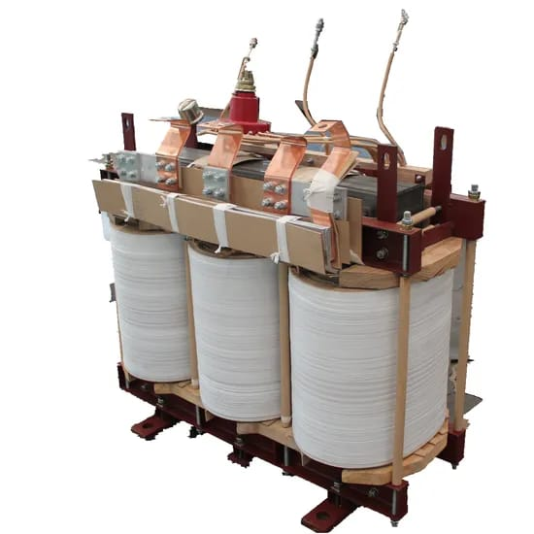

🔹 **What is an Insulation Cutting Machine?
An** Insulation Cutting Machine** is a specialized machine used to cut electrical insulation materials (like pressboard, kraft paper, crepe paper, or Nomex) into various shapes and sizes required for insulating components inside a transformer — such as windings, spacers, ducts, barriers, end rings, and supports.

These components ensure electrical isolation, mechanical support, and thermal protection inside the transformer.

⚙ Working Principle of the Insulation Cutting Machine
The machine cuts flexible or semi-rigid insulation materials using manual, semi-automatic, or fully automatic mechanisms. The cutting is done via:
Rotary blades,
Straight shear blades,
Die punching, or
CNC knife/laser cutting,
depending on the type and complexity of the required shape.
The basic working process includes:
Feeding insulation material (sheet or roll).
Measuring and aligning material.
Cutting using blades, dies, or a CNC system.
Collecting or stacking the cut pieces.

🛠 Main Components and Functions
Component Function
Feeding Mechanism Feeds insulation material into the machine (manual or motorized rollers).
Cutting Blade/Tool Cuts the material to the programmed size or shape.
Tension Control System Maintains uniform tension on the roll/sheet during feeding.
Control Panel Allows operator to set dimensions, shape, and quantity.
Conveyor or Stacking Area Receives cut pieces for collection or further assembly.
Sensors and Guides Ensure precision in length, angle, and position.

🔄 Types of Insulation Cutting Machines
Machine Type Description
Manual Cutting Machine Operated by hand, suitable for small workshops.
Semi-Automatic Cutter Motorized blades with manual feeding or alignment.
Fully Automatic CNC Cutter Program-controlled, precise cutting of complex shapes (rectangular, arc, notched, etc.).
Rotary Die Cutter Uses rotary dies to cut insulation from rolls for fast, repetitive tasks.
Laser/Knife CNC Cutter Advanced machines used for precise, burr-free cutting of detailed insulation profiles.

📐 Technical Specifications (Typical CNC Insulation Cutter)
Parameter Value (Range)
Material Thickness 0.2 mm – 10 mm
Max Cutting Width 500 mm – 1500 mm
Cutting Speed Up to 1000 mm/sec
Accuracy ±0.3 mm to ±0.5 mm
Blade Types Rotary, straight, V-notch, or oscillating
Material Types Supported Pressboard, crepe paper, kraft, Nomex, PET
Control System PLC or touchscreen HMI

🧾 Step-by-Step Working Process
1. Material Loading
Sheet or roll of insulation material is mounted.
The machine is calibrated for thickness and type.

2. Parameter Setting
Operator selects the program or enters length, width, cut type, quantity.

3. Feeding & Alignment
Material is fed through rollers and aligned using sensors.

4. Cutting Operation
Blades or dies cut the material as per the set shape and dimension.

5. Collection
Cut pieces are collected manually or stacked automatically.

🧰 Applications in Transformer Manufacturing
LV and HV winding insulation barriers

Layer insulation and end rings
Pressboard blocks and spacers
Duct strips for cooling channels
Cylinder wrapping for coils
Core insulation blocks

✅ Advantages
High cutting precision, consistent quality
Saves time in mass production
Reduces material wastage
Enables cutting of complex shapes with holes, notches, arcs
Minimal human error compared to manual cutting

❌ Challenges and Maintenance
Issue Solution
Blade wear or dullness Regular sharpening or replacement
Dust accumulation from materials Frequent cleaning of machine and filters
Misalignment of sheets Use auto-alignment and sensor-guided feeding
Material tearing or jamming Adjust tension and blade pressure according to material thickness
Software glitches (CNC types) Regular system updates and backup of programs

🛡 Safety Precautions
Use gloves and safety glasses during manual feeding.
Keep hands away from blades while operating.
Ensure emergency stop button is functional.
Regularly check for loose components or electrical faults.

_______________________________________________________________________

Vapour Phase Drying (VPD) Oven & Hot Air Oven – Detailed Working and Comparison

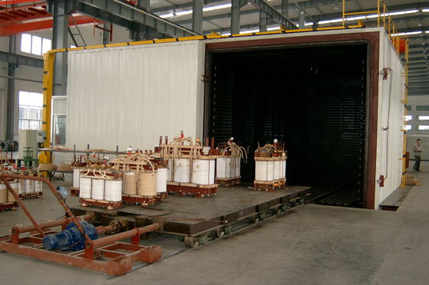
🔹 Purpose of Drying in Transformer Manufacturing
Drying is essential to:
Remove moisture and trapped water vapor from windings, insulation, and core.
Improve dielectric strength of insulation.
Reduce the risk of partial discharge, flashover, or breakdown in service.
Ensure long-term reliability of the transformer.

🔧 1. Vapour Phase Drying (VPD) Oven – Detailed Information
✅ What is VPD?
Vapour Phase Drying is an advanced and efficient method for drying core-coil assemblies using a vaporized solvent (like kerosene or white oil) that condenses on the colder transformer parts, transfers heat, and then evaporates moisture from the insulation.

⚙ Working Principle of VPD Oven
Solvent Heating:

A solvent (hydrocarbon like Dowtherm or white oil) is heated in a boiler to create hot vapor (up to 130–150°C).
Vapour Ingress into Vacuum Chamber:
The vapor enters the vacuum drying chamber containing the transformer core-coil assembly.
Condensation on Cold Surface:
The vapor condenses on the cooler surfaces of the assembly, releasing latent heat.
This heats up the insulation from inside out and evaporates absorbed moisture.
Evaporation and Removal of Moisture:
The released moisture is removed via vacuum pumps or condensate drains.
Repeat Cycles:
The process is repeated in cycles for uniform drying.

🛠 Main Components of VPD Oven
Component Function
Solvent boiler Heats solvent to generate vapor
Drying chamber Vacuum-tight chamber where drying takes place
Vacuum system Maintains low pressure for evaporation
Heat exchangers/Condensers Helps in condensation and collection of moisture
Control panel Controls temperature, pressure, and timing parameters
Safety valves & detectors Ensure safe operation and prevent explosion/fire risks

📐 Key Parameters
Parameter Typical Range
Temperature 120°C – 150°C
Vacuum Level 0.5 to 1 mbar (very low pressure)
Drying Time 8 – 24 hours (depends on size)
Solvent Used White oil / Dowtherm

✅ Advantages of VPD Oven
Faster and uniform drying

Less energy consumption than hot air ovens
Effective for thicker insulation systems
Ensures deep moisture removal
No oxidation of copper due to oxygen-free environment

❌ Challenges
High initial capital cost
Requires trained personnel
Solvent handling requires safety measures (flammable, toxic)
Complex control and monitoring system

🔧 2. Hot Air Oven – Detailed Information
✅ What is a Hot Air Oven?
A Hot Air Oven dries transformer components by circulating heated air inside a closed chamber. The heat removes moisture from insulation through evaporation.

⚙ Working Principle of Hot Air Oven
Heating Elements (electric or oil-based) heat the air inside the chamber.
Circulation Fans distribute hot air uniformly.
The core-coil assembly or insulation materials are placed inside the chamber.
As the hot air comes in contact with the materials, moisture is evaporated.
The moist air is expelled through vents or collected using condensers.

🛠 Main Components of Hot Air Oven
Component Function
Heating coils Heats the air inside the oven
Air circulation fan Ensures uniform temperature distribution
Temperature controller Maintains and adjusts drying temperature
Exhaust vent Removes moist air
Insulated chamber Retains heat and houses the materials

📐 Key Parameters
Parameter Typical Range
Temperature 80°C – 120°C
Drying Time 24 – 72 hours (slower)
Humidity Removal Through air vent or desiccant

✅ Advantages of Hot Air Oven
Lower cost and simpler to operate
Easy to install and maintain
Good for small to medium transformers
Suitable for insulation pre-drying

❌ Limitations
Slower than VPD
Not effective for thick windings or large power transformers
Possible uneven drying if airflow is poor
Risk of oxidation of copper at high temperature with open air

📊 Comparison: VPD Oven vs Hot Air Oven
Feature VPD Oven Hot Air Oven
Drying Speed Faster Slower
Energy Efficiency Higher Lower
Drying Depth Very deep (even internal insulation) Surface and mid-layer drying
Equipment Cost High Medium to Low
Operation Complexity Complex (needs trained operators) Simple
Copper Oxidation Risk None (vacuum environment) Possible (due to open air)
Suitability Large & power transformers Small & medium transformers

🛡 Safety Measures
Monitor temperature and pressure sensors regularly

Use explosion-proof equipment when working with solvents
Ensure ventilation and solvent recovery systems are working
Follow standard drying time cycles as per transformer design

_______________________________________________________________________

CNC Plasma Cutting Machine – Detailed Working
🔹 What is a CNC Plasma Cutting Machine?
A CNC Plasma Cutting Machine is used to cut metal sheets (typically mild steel, stainless steel, aluminum) into precise shapes and profiles using a high-velocity jet of ionized plasma controlled via CNC (Computer Numerical Control).

It is widely used in transformer manufacturing to cut tank walls, base plates, covers, brackets, flanges, etc.

⚙ Working Principle
Plasma Generation
An electric arc forms between a nozzle and the workpiece, converting compressed gas (like air, nitrogen, argon) into plasma.
Metal Cutting
The hot plasma (10,000°C–30,000°C) melts the metal, and high-velocity gas blows away the molten material, creating a clean cut.
CNC Control
The cutting path is programmed via CAD/CAM software and executed by the CNC system for automated and precise cutting.

🛠 Key Components
Component Function
Plasma torch Generates and directs the plasma arc
CNC controller Executes programmed cutting paths
Power supply Generates high-frequency current for plasma arc
Gas supply unit Provides compressed gas (air/N2/Ar)
Cutting table Holds metal sheets in place
Exhaust system Removes fumes and dust during cutting

📐 Key Parameters
Parameter Value/Range
Cutting thickness 1 mm – 50 mm (depending on material)
Cutting speed 500 mm/min – 3000 mm/min
Accuracy ±0.2 mm to ±0.5 mm
Material types MS, SS, Al, GI

✅ Advantages
High precision and speed
Cuts complex profiles and holes
Minimal edge finishing required
Less material waste

📘 2. Bending Machine – Detailed Working
🔹 What is a Bending Machine?
A Bending Machine (also called a Press Brake) is used to bend or form metal sheets into predefined angles or shapes, such as angles, channels, U-profiles, etc. It is essential in shaping transformer tanks, side walls, base frames, and enclosures.

⚙ Working Principle
The metal sheet is placed between a punch and a die.
The hydraulic press or mechanical ram pushes the punch down onto the metal, bending it into the die shape.
The bending angle is controlled by depth of punch movement and die shape.

🛠 Main Components
Component Function
Upper punch Applies force to bend the sheet
Lower die Supports the sheet and determines bend angle
Back gauge Positions the sheet for accurate bends
Hydraulic system Drives the ram (punch movement)
Control panel Sets bend angle, pressure, and stroke depth

📐 Key Parameters
Parameter Typical Range
Bending capacity 1 mm – 20 mm sheet thickness
Bending angle range 0° – 180°
Material types Mild steel, stainless steel, aluminum
Machine type Hydraulic or mechanical

✅ Advantages
Consistent and repeatable bending
Can perform multiple bends on one part
High productivity and precision
Suitable for mass production of transformer parts

📘 3. Welding Machine – Detailed Working
🔹 What is a Welding Machine?
A Welding Machine is used to join metal parts (like transformer tank sides, covers, brackets, pipes) by melting and fusing the edges together, sometimes using filler material. Common methods include MIG (GMAW), TIG (GTAW), and Arc (SMAW) welding.

⚙ Working Principle
Electric arc is generated between the electrode and workpiece.
Heat from the arc melts the metal at the joint.

Filler metal may be added to strengthen the weld.
The molten pool solidifies to form a strong welded joint.

🛠 Main Components
Component Function
Welding torch/gun Directs arc and filler wire to weld zone
Power source Supplies welding current and voltage
Ground clamp Completes the electrical circuit
Gas supply (MIG/TIG) Provides shielding gas (Argon/CO₂) to protect the weld
Filler wire/feed Supplies metal for joint (MIG or TIG)

📐 Types of Welding Used in Transformer Fabrication
Welding Type Description & Use
MIG Welding Fast, semi-automatic welding used for tank walls and larger joints
TIG Welding Precise, clean welding for thinner parts and stainless steel
Arc Welding Common for structural frames and brackets (manual operation)

✅ Advantages
High strength joints
Custom shapes and assemblies possible
MIG/TIG offer clean, spatter-free finish
TIG gives better control for thin parts

❌ Common Issues & Precautions
Issue Precaution
Warping due to heat Use controlled heat input and clamps
Incomplete fusion Proper current settings and electrode angle
Weld spatter Use gas shielding and correct polarity
Joint misalignment Use fixtures and templates

✅ Summary of Uses in Transformer Manufacturing
Machine Type Main Applications
CNC Plasma Cutter Cutting tank panels, cover plates, flanges, base plates
Bending Machine Bending sheets into U channels, tanks, enclosures, mounting frames
Welding Machine Joining transformer tank panels, frames, stiffeners, bushing pockets, pipes

Vacuum Oil Filling Machine – Detailed Working and Information
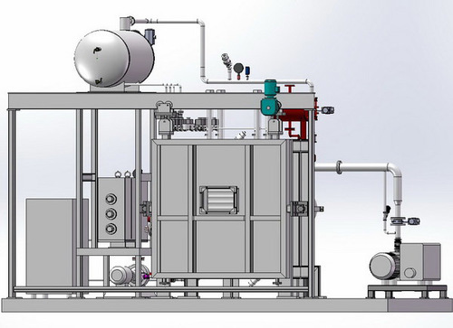

🔹 **What is a Vacuum Oil Filling Machine?
A Vacuum Oil Filling Machine** is a specialized system used to fill insulating oil (typically mineral or ester oil) into power and distribution transformers under vacuum conditions. The purpose is to remove trapped air/moisture from the windings and insulation and to completely impregnate the internal structure with dielectric oil, ensuring proper insulation and cooling of the transformer.

🎯 Objectives of Vacuum Oil Filling
Remove moisture and gases from insulation and windings
Ensure complete oil penetration into gaps and layers
Prevent air pockets, which can cause partial discharges or flashover
Improve the dielectric strength of the transformer
Ensure long-term reliability and performance

⚙ Working Principle of Vacuum Oil Filling Machine
The process works by creating a deep vacuum inside the transformer tank before and during oil filling. This low-pressure environment allows the oil to flow and impregnate windings deeply, without air resistance or trapped bubbles.

🔧 Step-by-Step Working Process
1. Preheating the Oil
Oil is filtered and heated to 50–60°C using an inline heater.
Heated oil has lower viscosity, improving flow and penetration.

2. Evacuation of Transformer Tank
The transformer tank is connected to the vacuum system.

A deep vacuum is drawn (up to 0.5–1 mbar) to remove air and moisture from windings and insulation.

Vacuum is maintained for several hours depending on transformer size.

3. Oil Filling Under Vacuum
With vacuum still applied, hot, filtered oil is filled from the bottom of the transformer.

Bottom filling avoids air entrapment and promotes uniform soaking of the coils.

The filling is done gradually to avoid stress on insulation.

4. Soaking Time
The transformer is kept under vacuum with oil filled to allow full absorption of oil into insulation layers.

5. Venting and Final Top-Up
Once filling is complete and soaking time has passed, the vacuum is slowly released.

Oil level is topped up to the required level before sealing the transformer.

🛠 Main Components of the Machine
Component Function
Vacuum Pump System Creates and maintains deep vacuum in transformer tank
Oil Heating Unit Heats oil to reduce viscosity and enhance flow
Oil Filtration Unit Removes moisture, gases, and particles from insulating oil
Oil Transfer Pump Transfers oil from reservoir to transformer tank
Control Panel (PLC) Manages vacuum level, temperature, pressure, flow rate, and alarms
Hoses/Connectors Connect transformer to oil and vacuum systems
Moisture & Gas Indicators Monitor oil quality before and after filling

📐 Typical Technical Parameters
Parameter Typical Value
Operating Vacuum 0.1 – 1 mbar (very low pressure)
Oil Temperature 50°C – 65°C
Oil Flow Rate 500 – 5000 L/hr (depends on transformer size)
Filtration Accuracy < 1 micron
Residual Moisture in Oil < 10 ppm (post-filtration)

✅ Advantages of Vacuum Oil Filling
Ensures deep impregnation of insulating materials
Removes air pockets and moisture traces from core and coils
Enhances dielectric strength and thermal conductivity
Improves long-term reliability of transformers
Suitable for large power transformers, reactors, and bushings

❌ Common Challenges & Solutions
Issue Solution
Incomplete vacuum or leaks Check seals, hoses, and vacuum chamber integrity
Foaming or bubbling during filling Fill slowly and monitor temperature/vacuum closely
Moisture not fully removed Increase vacuum time or improve oil filtration
Overheating of oil Use auto temperature controllers with alarm settings

🛡 Safety Measures
Ensure all valves and hoses are sealed before starting vacuum
Maintain temperature and pressure within limits
Use anti-static grounding to prevent spark during oil transfer
Never open transformer tank during vacuum filling
Use fire-resistant oil and explosion-proof motors where necessary

🏭 Applications in Transformer Manufacturing
Power Transformers (33 kV – 400 kV and above)
Distribution Transformers
Shunt Reactors
OLTC (On Load Tap Changer) chambers
HV Bushings and Insulated Devices

__________________________________________________________________________

High Voltage (HV) Testing Equipment – Detailed Information & Working
🔹 Purpose of HV Testing
High Voltage (HV) Testing is performed to:
Confirm the transformer insulation can withstand service voltage and overvoltages.
Detect any weak spots, internal faults, or partial discharges.
Ensure compliance with international standards (IEC, IS, ANSI).

⚙ Types of HV Tests Conducted
Test Name Purpose
Power Frequency Withstand Test Verifies insulation strength at rated frequency
Insulation Resistance Test Measures resistance of insulation material
Leakage Current Test Detects partial discharges or breakdown risk
Applied Voltage Test Applies test voltage for 1 minute

🔧 Working Principle of HV Testing
A step-up transformer increases the input voltage to test level (e.g., 30 kV, 60 kV, 100 kV, etc.).
The test voltage is applied between:
HV winding and earth
HV to LV winding
LV winding and earth
The voltage is maintained for 1 minute (typically), and the leakage current is monitored.
If the insulation withstands the voltage without breakdown or flashover, the test is passed.

🛠 Main Components
Component Function
HV Test Transformer Steps up voltage to test level
Control Panel Manages output, test time, current limits, safety shutoff
Capacitive Divider Measures actual applied voltage accurately
Leakage Current Meter Measures current leakage (sensitive in microamperes)
Safety Cage Ensures operator safety during high voltage exposure

📐 Typical Parameters
Parameter Value/Range
Output Voltage 10 kV – 300 kV
Test Duration 1 min to 5 min
Leakage Current < 10 mA (varies by test object)
Frequency 50 Hz / 60 Hz

✅ Advantages
Non-destructive (in routine testing)
Reveals insulation degradation or manufacturing defects
Quick and reliable pass/fail assessment
Used for routine and type testing

❌ Safety Precautions
No one should touch the equipment during testing
Use proper earthing and interlocks
Test area should be enclosed with insulated floor and warning signs
Discharge stick must be used after test before touching the transformer

📘 2. Impulse Test Machine – Detailed Information & Working
🔹 What is Impulse Testing?
Impulse Testing is used to simulate lightning strikes or switching surges that may occur in service. It verifies the transformer’s ability to withstand transient overvoltages.

⚙ Working Principle of Impulse Test Machine
The system uses large capacitors charged to a high voltage (up to 1600 kV).

When discharged through a special wave shaping network (resistors & inductors), it creates a lightning impulse waveform:

e.g., 1.2 / 50 μs (rise time/fall time)
The impulse is applied between:
HV winding and earth
HV to LV winding
Or across windings for chopped wave tests
The resulting waveform is captured and compared to the expected impulse shape.
A failure is indicated by:

Waveform distortion
Flashover
Unusual oscillations or sudden drop in peak

🛠 Main Components
Component Function
Impulse Generator Produces high-voltage impulse by discharging capacitors
Charging Unit Charges the capacitors to high voltage
Wave-shaping Network Shapes the voltage pulse to simulate lightning/switching surge
Measuring System Uses voltage dividers and oscilloscope to capture waveform
Test Controller Panel Synchronizes charging, triggering, and measurement

📐 Impulse Wave Types
Type of Impulse Application
Full Lightning Impulse Simulates actual lightning (1.2/50 μs)
Chopped Lightning Impulse Tests insulation near bushings
Switching Impulse Used for UHV (Ultra High Voltage) units

📐 Typical Test Parameters
Parameter Value/Range
Peak Voltage 100 kV – 1600 kV
Impulse Shape 1.2 μs rise / 50 μs fall (standard)
No. of Impulses 3 to 5 full waves + 2 chopped waves
Repetition Rate 1 impulse every 30–60 seconds

✅ Advantages
Accurately simulates real-world voltage surges
Detects weak points, especially in inter-turn insulation
Essential for type testing and special transformers
Captures failure points early to avoid costly field failure

❌ Precautions
Operate only by trained personnel
Keep the test area cleared and grounded
Use shielded rooms or faraday cages for sensitive instruments
Disconnect transformer from external circuitry

🏭 Use in Transformer Manufacturing
Machine Stage of Use Applies To
HV Testing Equipment Final testing before dispatch All transformers
Impulse Test Machine Type testing / special transformers Power transformers, HV distribution

__________________________________________________________________________

Spray Painting Booth & Powder Coating Booth
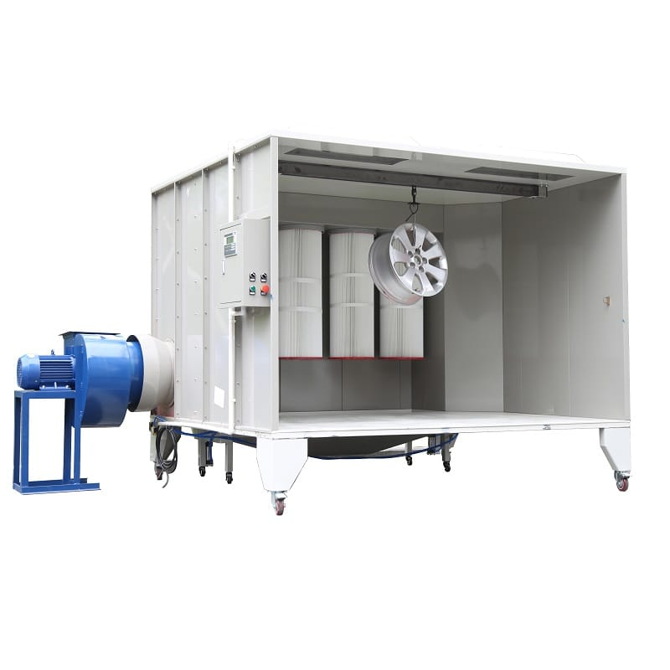
🛠 Why Painting or Coating is Done in Transformer Manufacturing?
Painting or powder coating serves the following purposes:
Corrosion resistance (especially for outdoor installations)
UV and weather protection
Electrical insulation in specific areas
Improved appearance and branding
Longer lifespan of transformer tanks and metal parts

📘 1. Spray Painting Booth – Detailed Working
🔹 What is a Spray Painting Booth?
A Spray Painting Booth is an enclosed area where liquid paint is sprayed onto metal parts like transformer tanks, base frames, and covers using compressed air spray guns. It includes ventilation, filtration, and overspray control.

⚙ Working Principle of Spray Painting Booth
Surface Preparation:
The transformer tank or part is cleaned, degreased, and shot/blast-cleaned.
Ensures paint adhesion.
Primer Application:
A corrosion-resistant primer (e.g., zinc-rich or epoxy) is applied.
Spray Coating:
A spray gun atomizes liquid paint using compressed air, forming a mist.
Paint is sprayed evenly over the surface inside the booth.
Drying/Curing:
Parts are moved to a drying area (air-dried or baked in an oven if required).
Some booths have built-in heating for faster drying.
Final Coat:
After primer, topcoat (PU/epoxy/enamel) is applied for finish and protection.

🧰 Main Components of Spray Booth
Component Function
Spray gun Atomizes paint using compressed air
Compressor Supplies air to spray gun
Paint pump/system Delivers liquid paint from container to gun
Enclosure walls Prevent overspray and dust contamination
Air exhaust system Pulls out paint mist and fumes
Filters Capture overspray and dust particles
Lighting Ensures clear visibility while spraying

📐 Technical Parameters
Parameter Typical Range
Paint Type Epoxy, enamel, PU
Air Pressure 4–6 bar
Film Thickness 80–120 microns (dry film)
Drying Time 2–12 hours depending on paint type
Airflow Type Downdraft or crossdraft

✅ Advantages of Spray Painting
Uniform finish with minimal surface defects
Works on complex shapes and edges
Can be used for large parts like full transformer tanks
Easier for touch-up and field repair

❌ Disadvantages
Paint contains solvents and VOCs (environmental concern)
Requires longer drying/curing time
Manual spray skill affects finish quality

📘 2. Powder Coating Booth – Detailed Working
🔹 What is a Powder Coating Booth?
A Powder Coating Booth is used to apply electrostatically charged powder paint (no liquid/solvent) onto grounded metal parts. After coating, parts are baked in an oven, where the powder melts and cures into a hard, protective film.
It is used in transformer manufacturing for:
Radiators
Control boxes
Terminal covers
LV & HV metal accessories

⚙ Working Principle of Powder Coating
Surface Cleaning:
Parts are cleaned using phosphate wash or sand blasting.
Powder Spray Application:
Powder paint particles are negatively charged in the gun.
The metal part is electrically grounded.
Electrostatic attraction causes powder to stick to the surface.
Curing in Oven:
The coated part is baked at 160–220°C for 15–30 minutes.
Powder melts, flows, and forms a solid, durable coating.

🧰 Main Components of Powder Coating Booth
Component Function
Electrostatic spray gun Charges powder particles and sprays them
Powder hopper Stores and delivers powder to gun
Control panel Adjusts voltage, powder feed rate, and spray settings
Booth enclosure Contains overspray
Recovery unit Recovers unused powder for reuse
Curing oven Bakes the part to cure the powder coating

📐 Technical Parameters
Parameter Typical Range
Voltage at gun 30–100 kV
Coating Thickness 60–100 microns
Curing Temperature 160–220°C
Curing Time 10–30 minutes
Powder Types Epoxy, polyester, hybrid

✅ Advantages of Powder Coating
No solvents, environmentally friendly

Hard, durable finish resistant to scratches, corrosion, and UV
High transfer efficiency (up to 98% with recovery system)
Minimal overspray wastage
Available in various colors and textures

❌ Disadvantages
Requires high-temperature oven for curing
Difficult to coat inside corners or hollow areas
Not suitable for non-metallic parts
Color change requires complete gun and booth cleaning

📊 Spray Painting vs Powder Coating – Comparison
Feature Spray Painting Powder Coating
Paint Type Liquid (solvent-based) Dry powder (electrostatic)
Drying Method Air dry or heat Curing in oven
Film Hardness Medium Very Hard
Environmental Impact High VOCs Eco-friendly (no VOCs)
Suitable for Large Parts Yes (like tanks) Limited (depends on oven size)
Color Flexibility High Medium (requires full cleaning to change)
Durability Moderate to High Very High

🛡 Safety Measures
Use PPE: respirator mask, gloves, eye protection
Spray booths must have exhaust and filtration systems
No open flames or sparks near powder or paint booths
Handle powders with static grounding to prevent fire risk
Maintain booth cleanliness to avoid contamination

