- Create/update Tag templates
URL: https://retailpos.iconnectgroup.com/Api/tags/addEdit.php
Method: POST
JSON:
{
"company_code" : "afhstXDev", // Need to pass compnay code
"id" : 2, // for insert data it’s 0 else whatever it is
"template_name" : "Template 2",
"config_1" : "<html><h1>Template 2!!! <h1></html>",
"config_2" : "",
"page_size" : "A4",
"is_web":"1", // from web it is 1 else 0
"template_html" : ",
"created_by" : "Admin",
"updated_by" : "Admin"
}
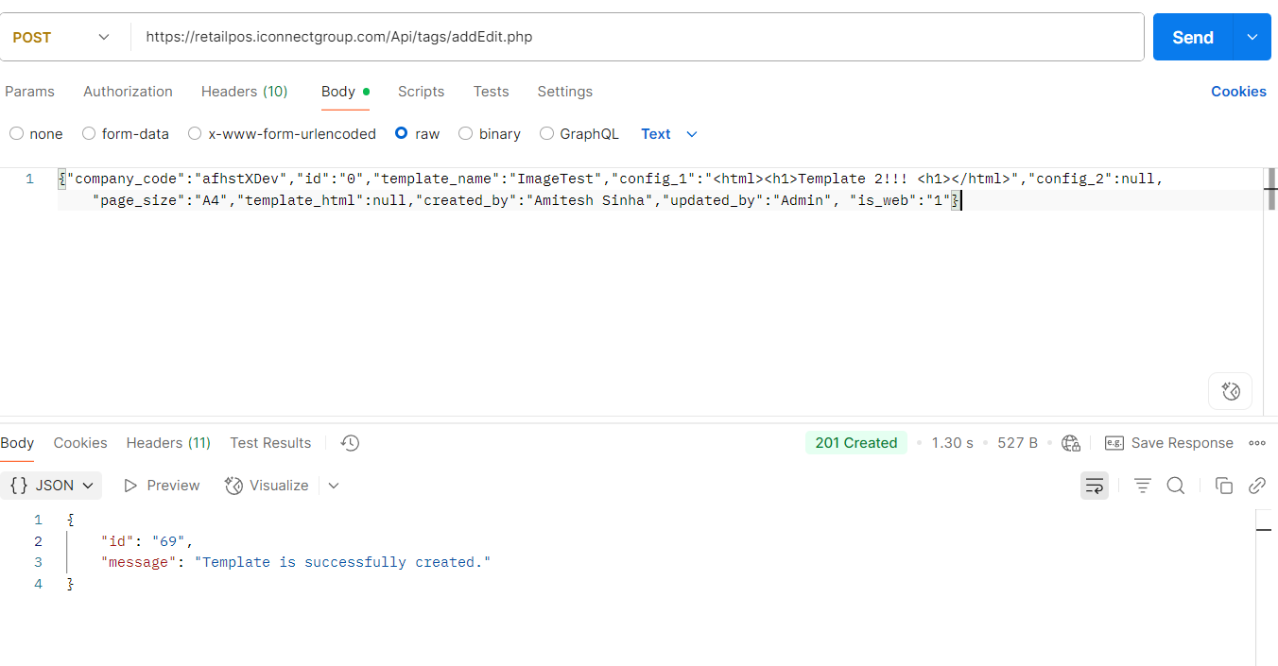

- List Templates
URL: https://retailpos.iconnectgroup.com/Api/tags/list.php?company_code=afhstXDev
Method: GET
Parameters: company_code, id, is_web (1 or 0)

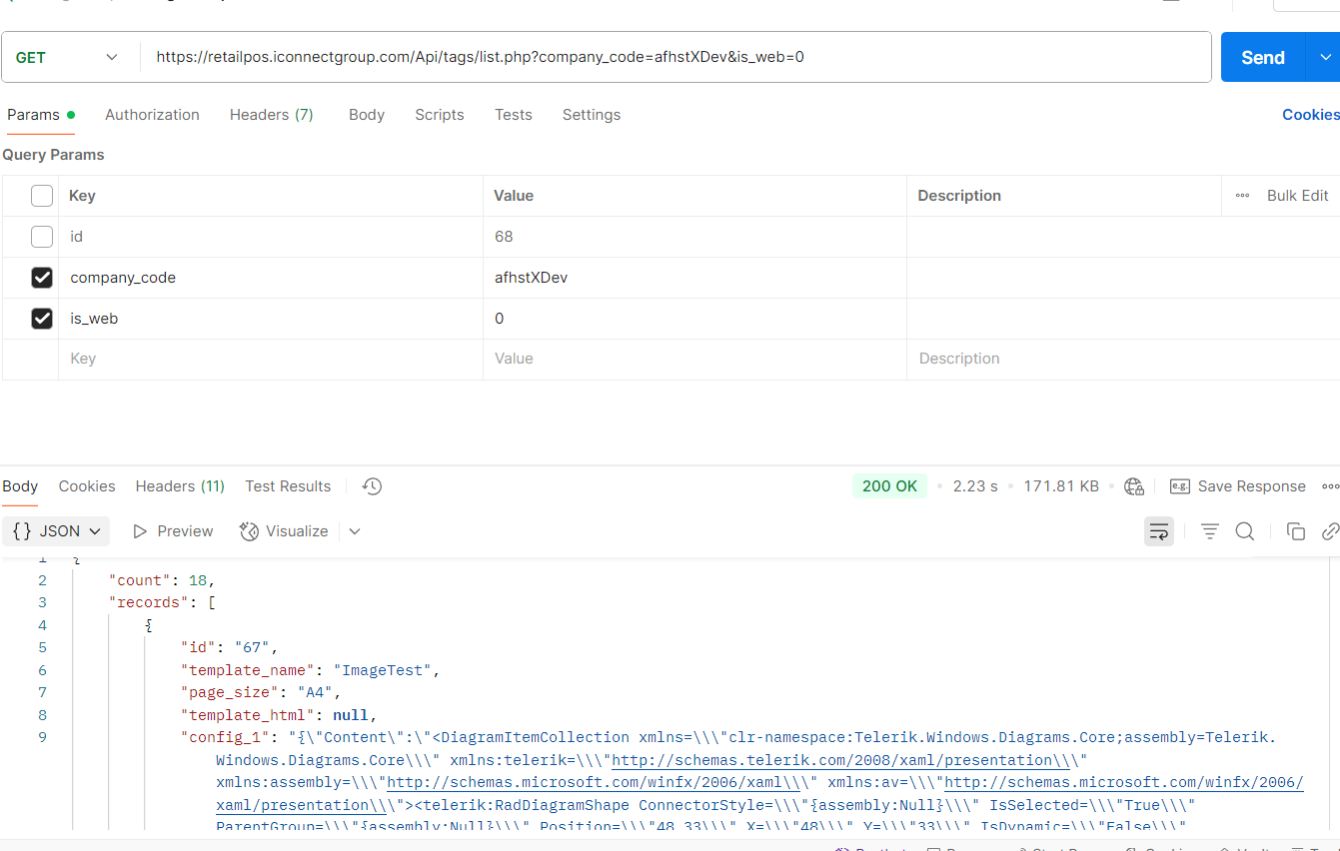

- List templates details by ID
URL: https://retailpos.iconnectgroup.com/Api/tags/list.php?company_code=afhstXDev&id=2
Method: GET

- Delete template
URL: https://retailpos.iconnectgroup.com/Api/tags/delete.php
Method: POST
BODY:
{
"company_code":"afhstXDev",
"id":"30"
}

- Get Items
URL - https://retailpos.iconnectgroup.com/Api/inventory/list.php?company_code=afhstXDev
Method: GET

- API to getting all categories and Sub categories
URL - https://retailpos.iconnectgroup.com/Api/category/list.php?company_code=afhstXDev
Method: GET

- Added sub_category_ids parameters to search by subcategory
URL https://retailpos.iconnectgroup.com/Api/inventory/list.php?company_code=afhstXDev&sub_category_ids=714
Method: GET

- GetAuthToken
URL: http://posapi.iconnectgroup.com/API/GetAuthToken
Method: GET
Parameters:
AuthCode : afhstXDev
grant_type : password
Response:
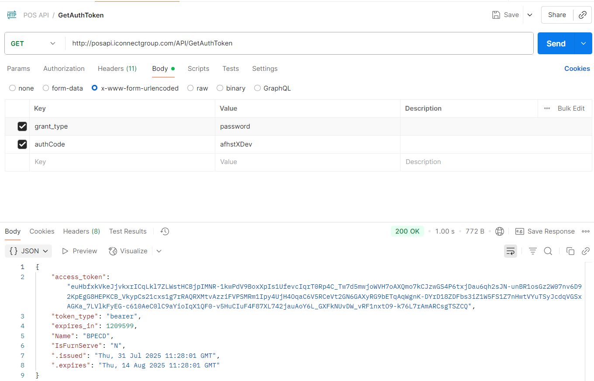

- User Login

URL: http://posapi.iconnectgroup.com/Api/Pos/UserLogin
Method: POST
Parameters:
UserName: a51nha
Password: ICon1234
Headers:
Authorization: bearer <access_token (which you get from getAuthToken API)>
Response:
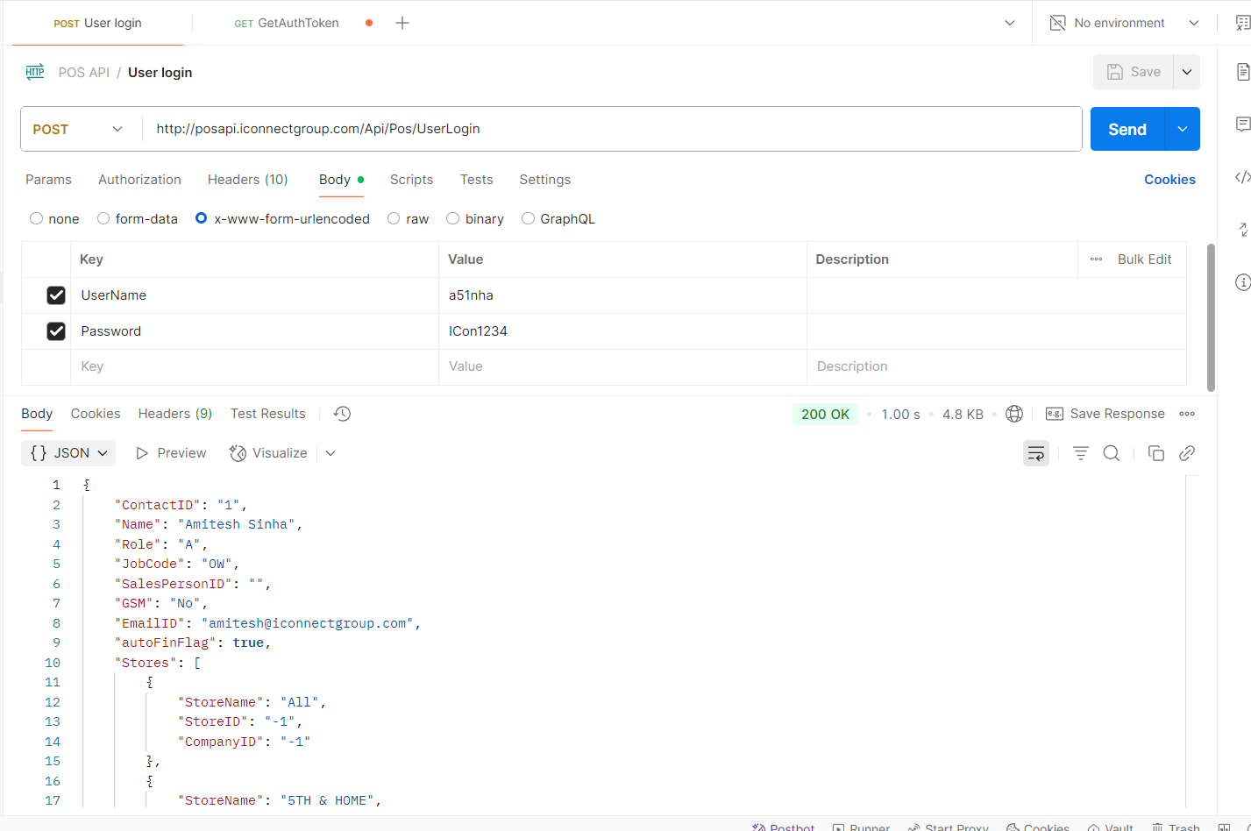

- Store tags API
URL: https://retailpos.iconnectgroup.com/Api/inventory/listSequenceItems.php?store_id=20&date=08/20/2024&template_id=36&company_code=afhstXDev
Method: GET
Parameters:
store_id: 20 (store id from dropdown)
date : 08/31/2025 (optional)
template_id: 36 (template id from dropdown)
company_code: afhstXDev
Response:
